WOMEN’S UNIVERSITY COMPLAINT REPORTING SYSTEM
Software Engineering- Class and Sequence Diagrams
1 UML Diagram
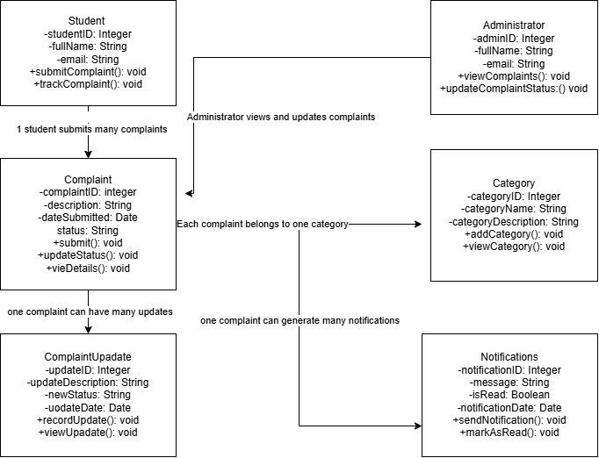

2. UML Sequence Diagram – Submit a Complaint

